**ST10355439**

**INSY7314**

**ICE Task 1**

**Links:**

**GitHub link:**

https://github.com/ST10355439/INST7314_Pulsevote.git

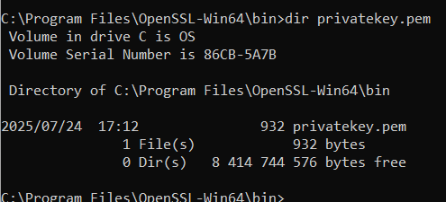

Figure 1: Image showing the created privatekey.pem file (Mc Harlies, 2025)

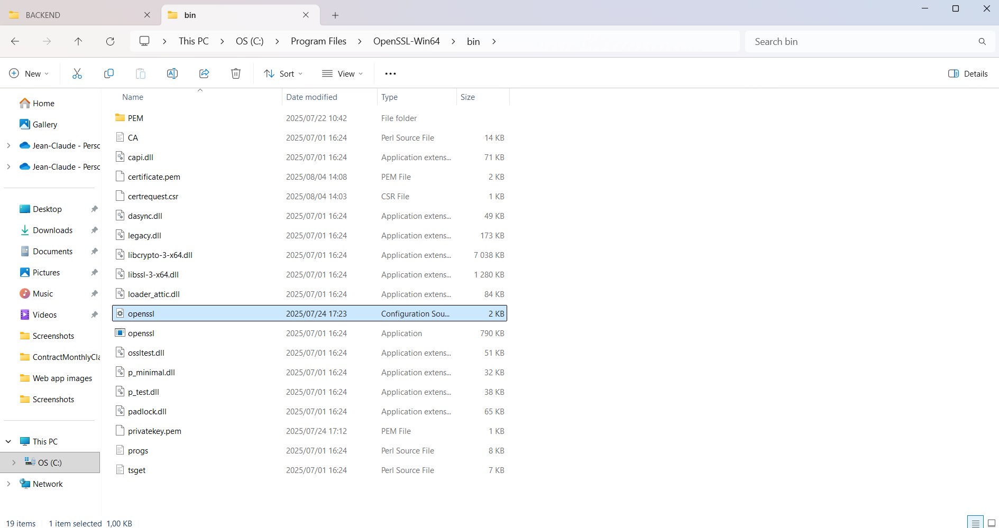

Figure 2: Image showing the created openssl.cfg file (Mc Harlies, 2025)

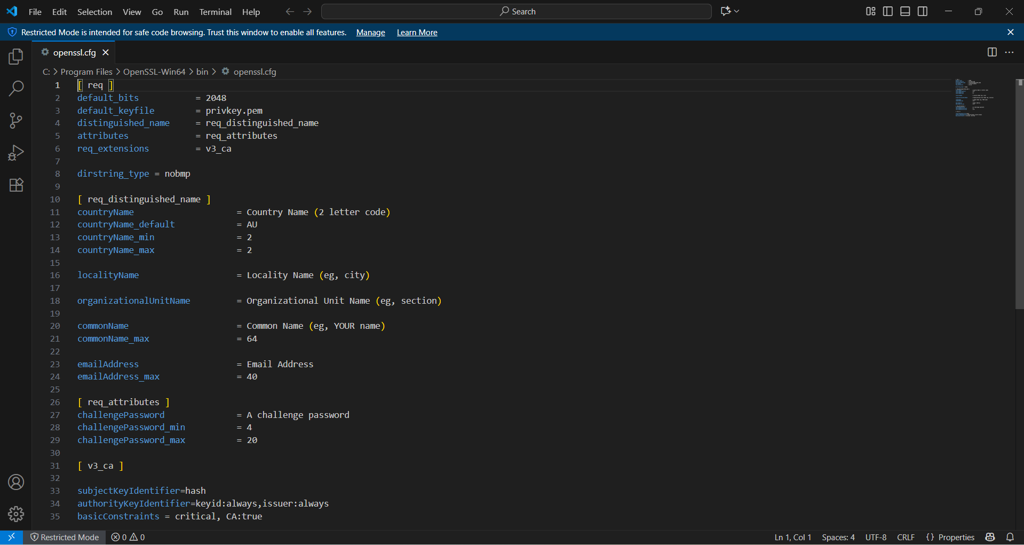

Figure 3: Image showing the contents of the openssl.cfg file (Mc Harlies, 2025)

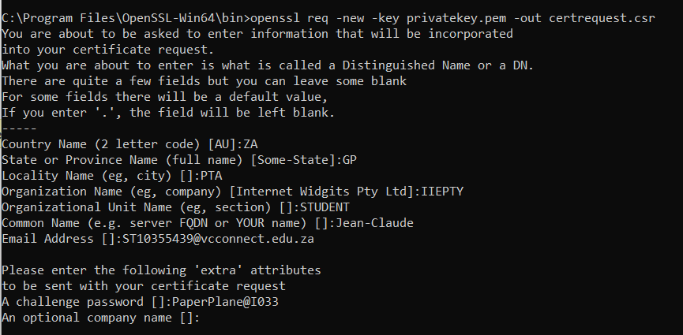

Figure 4: Image showing the creation of the certificate signing request (Mc Harlies, 2025)

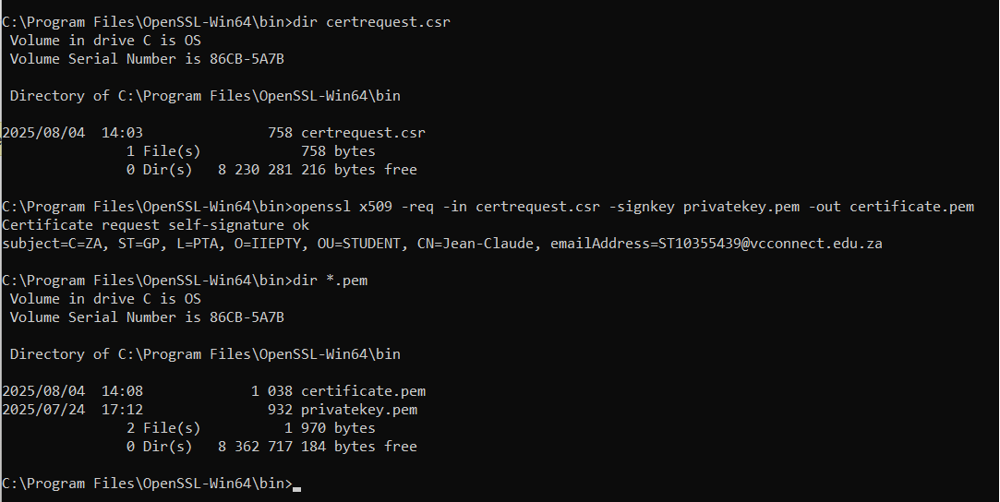

Figure 5: Image showing the signing of the certificate using the private key (Mc Harlies, 2025)

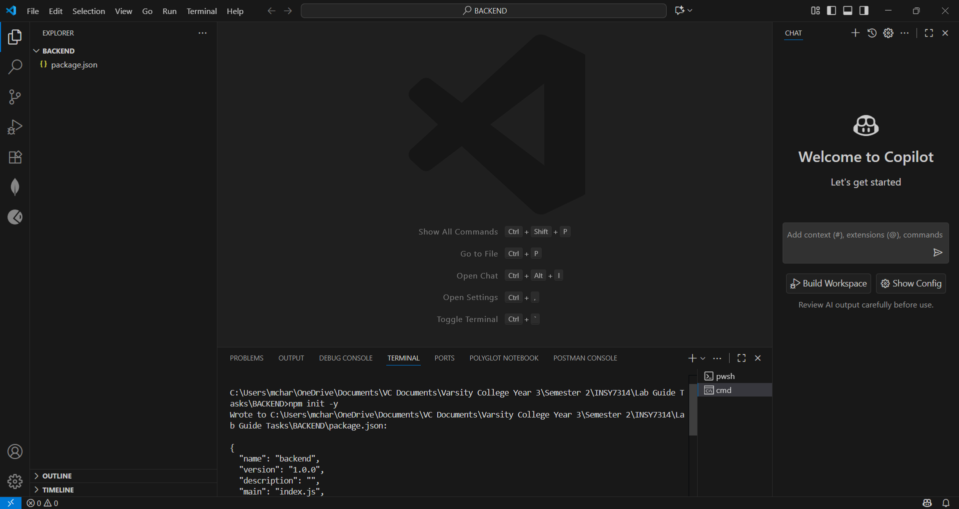

Figure 6: Image showing the creation of the package.json file (Mc Harlies, 2025)

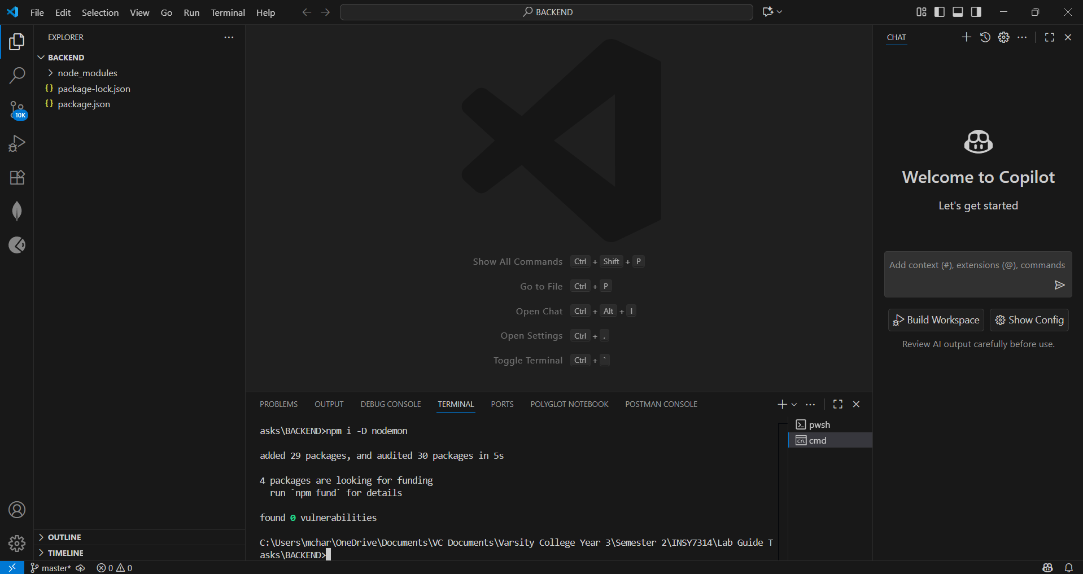

Figure 7: Image showing the installation of the nodemon package (Mc Harlies, 2025)

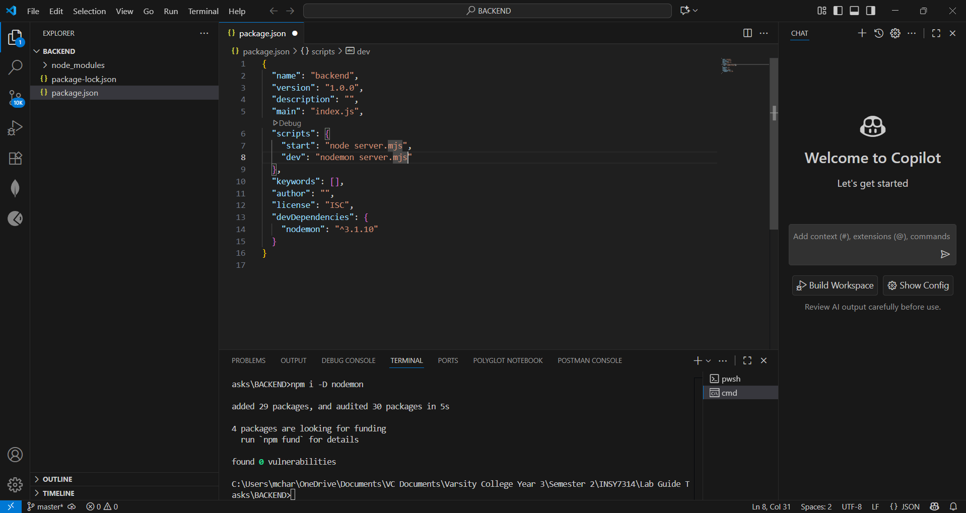

Figure 8: Image showing the changes made to the “scripts” section of the package.json file (Mc Harlies, 2025)

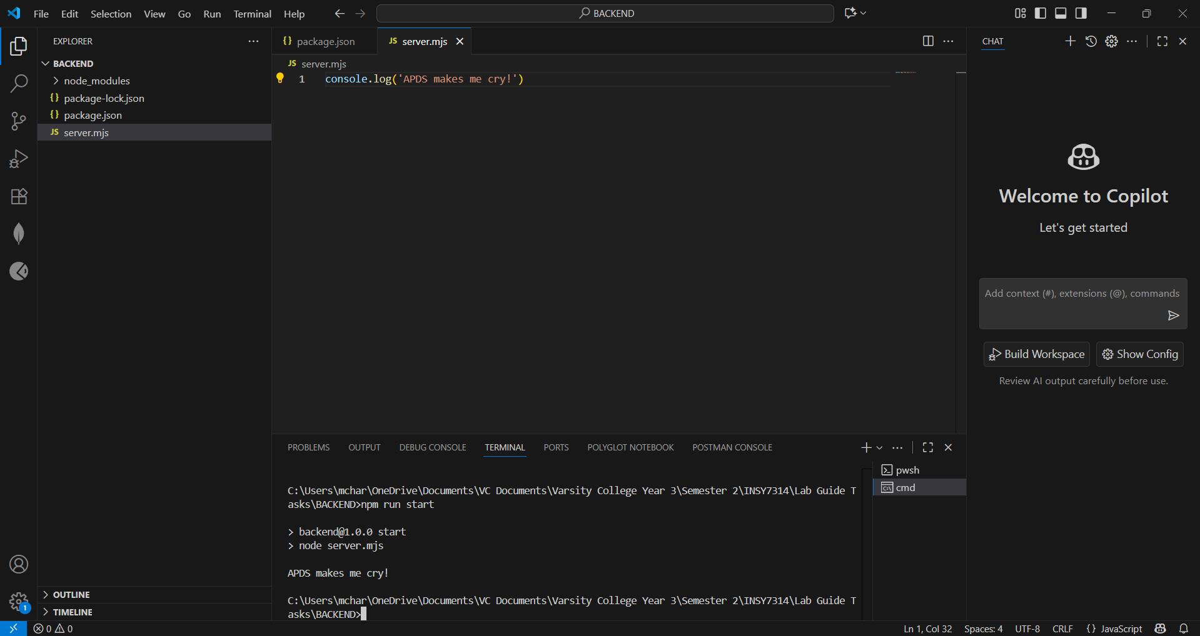

Figure 9: Image showing the created server.mjs file with the inserted console.log command, and the running of the node server (as per the “scripts” tag in the package.json file) in the terminal (Mc Harlies, 2025)

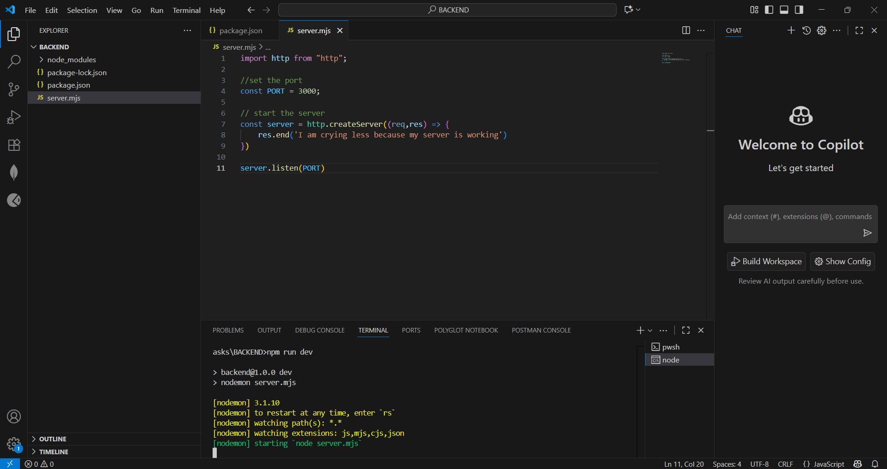

Figure 10: Image showing the changes made to the server.mjs file and the running of the node server as it would be run in production (Mc Harlies, 2025)

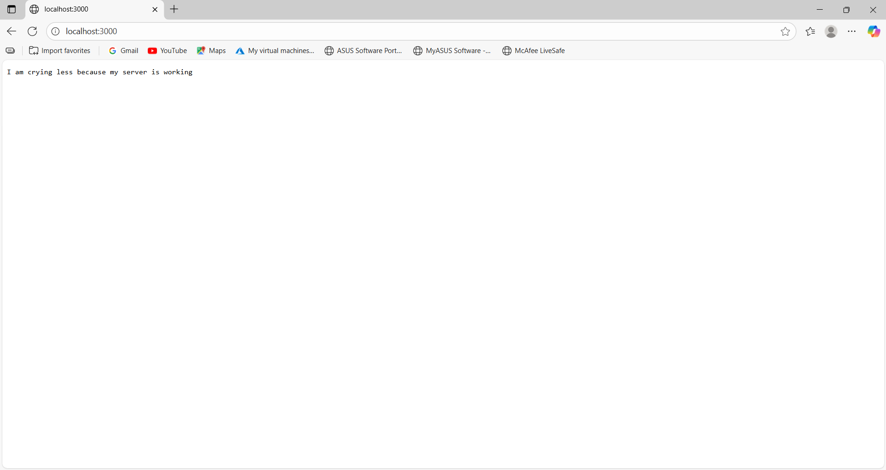

Figure 11: Image showing the output in the web browser after running the node server (Mc Harlies, 2025)

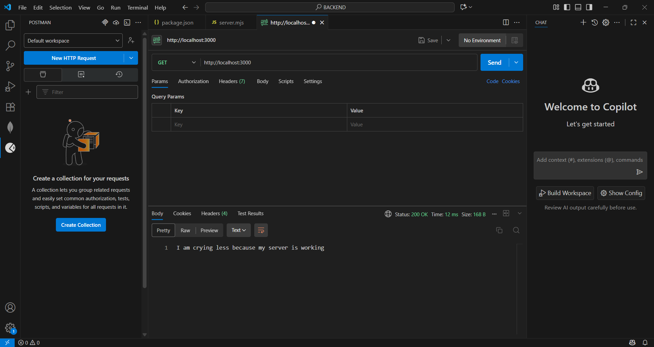

Figure 12: Image showing a get request to the server’s port using the Postman extension. The image is also showing the results of the request (Mc Harlies, 2025)

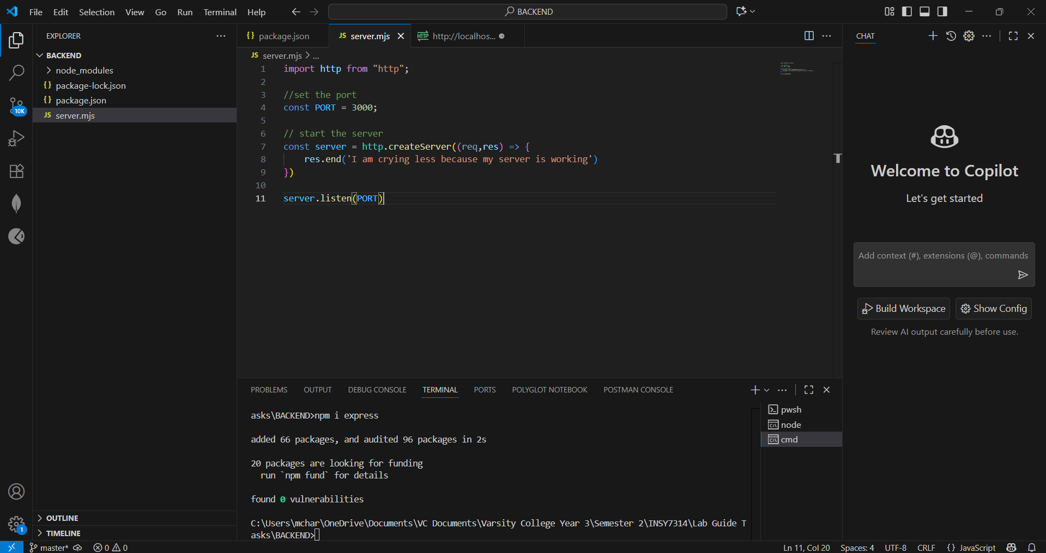

Figure 13: Image showing the installation of the express package using the terminal (Mc Harlies, 2025)

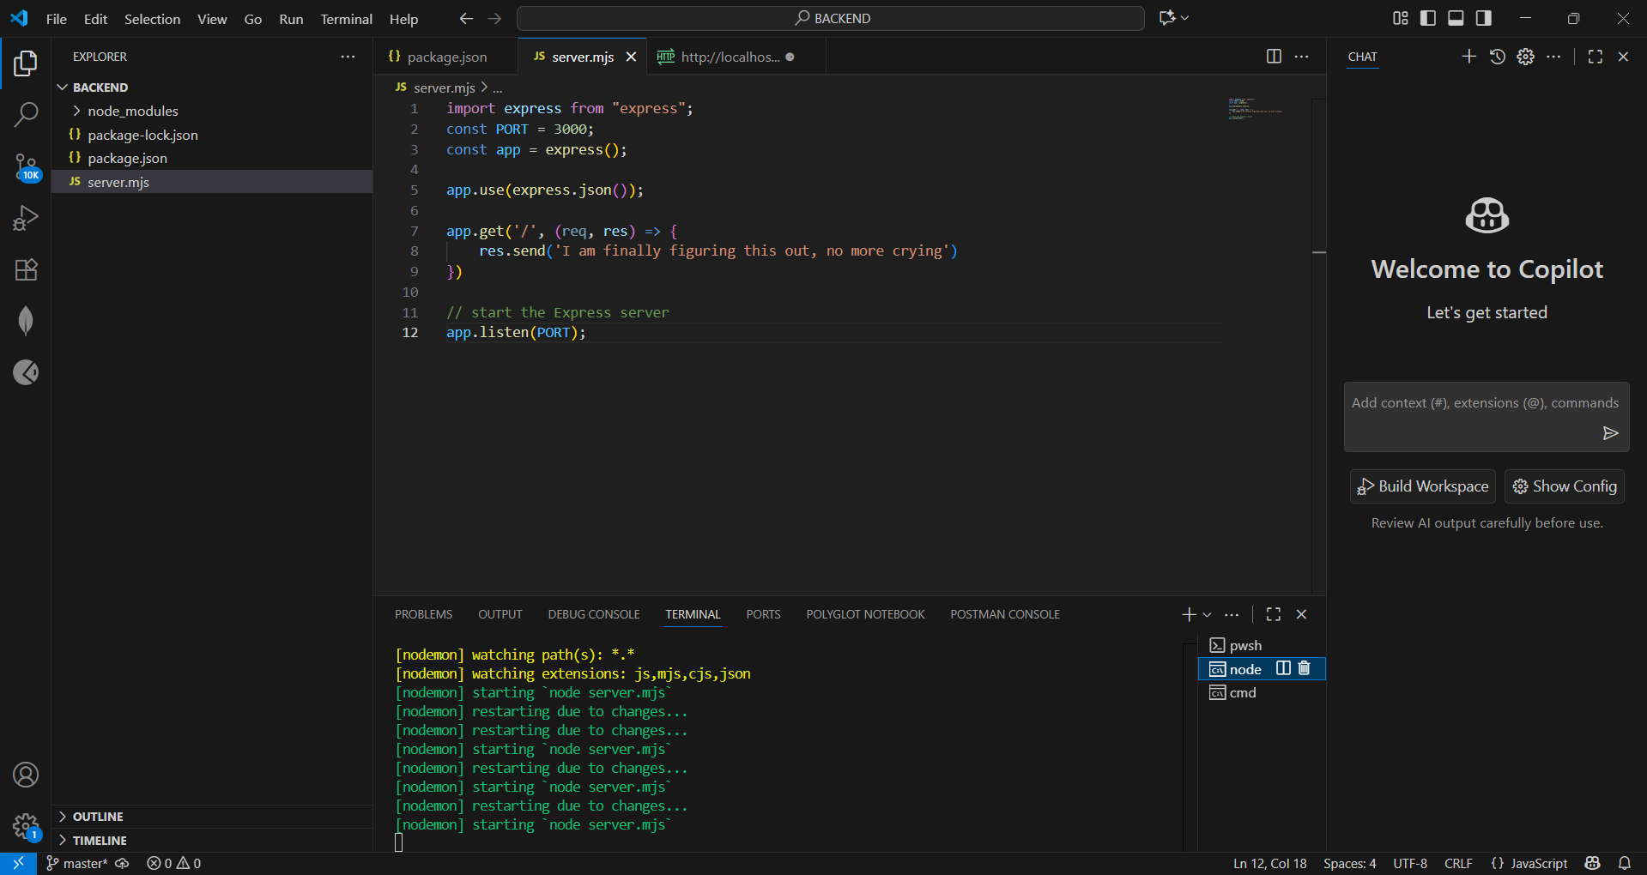

Figure 14: Image showing the changes made to the server.mjs file to use the express package features (Mc Harlies, 2025)

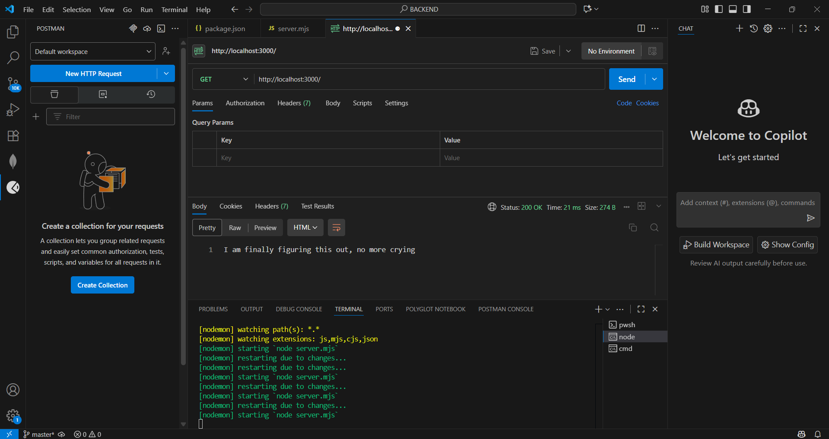

Figure 15: Image showing a get request with its results. The image shows that the server with its inclusion of express works (Mc Harlies, 2025)

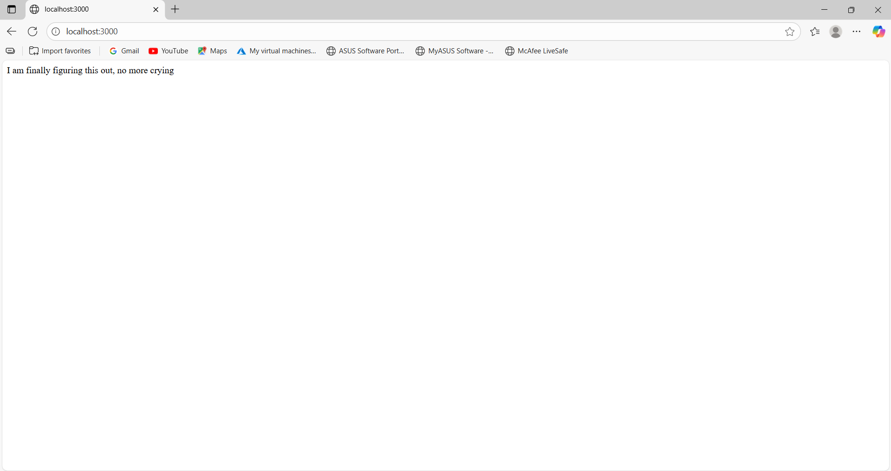

Figure 16: Image showing the output in the web browser after running the node server with the imported express package (Mc Harlies, 2025)

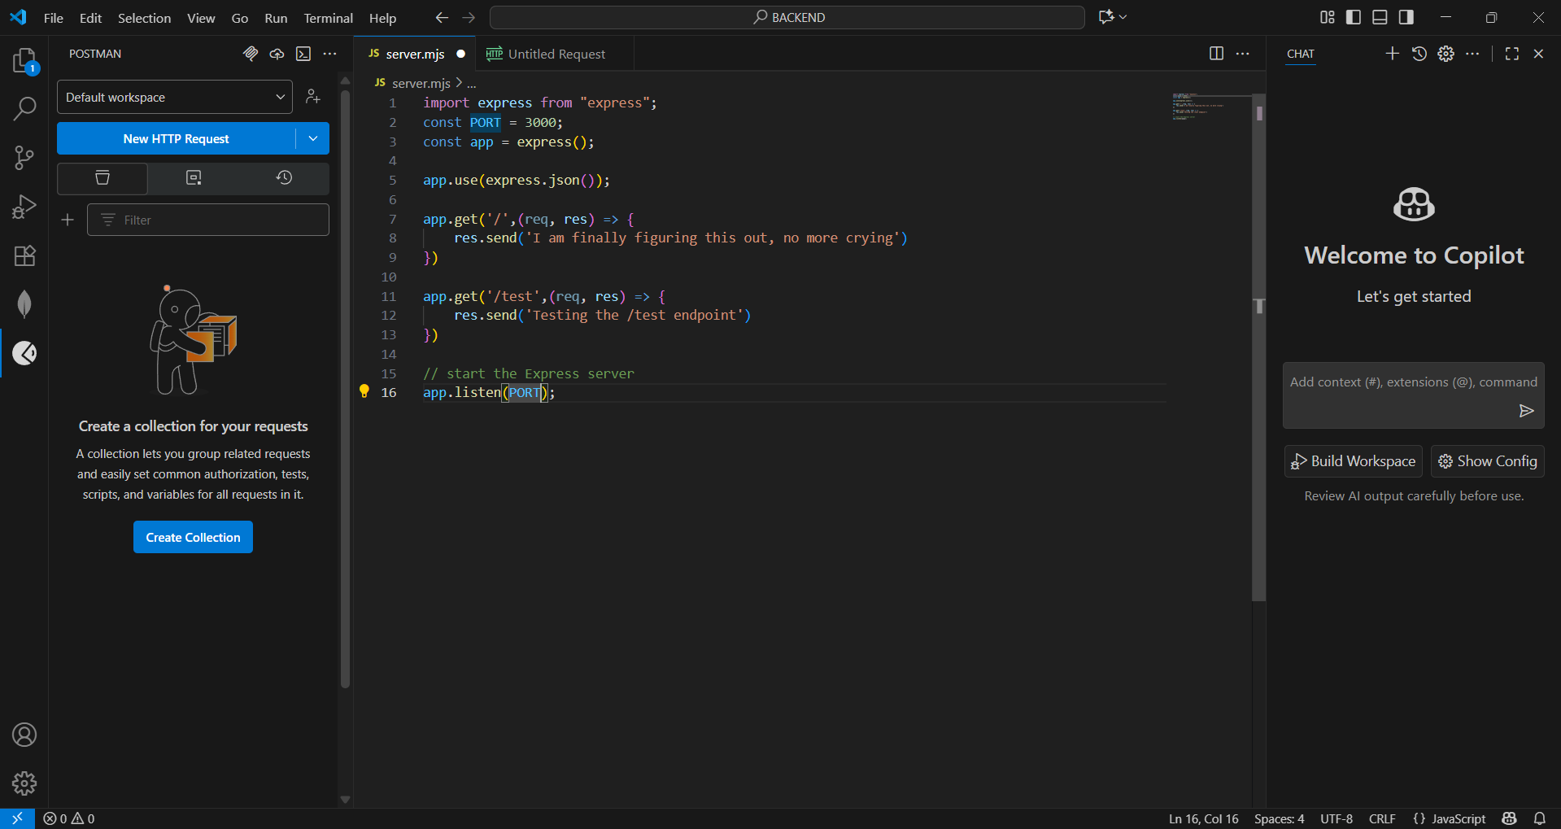

Figure 17: Image showing the changes made to the server.mjs file to use a testing endpoint (Mc Harlies, 2025)

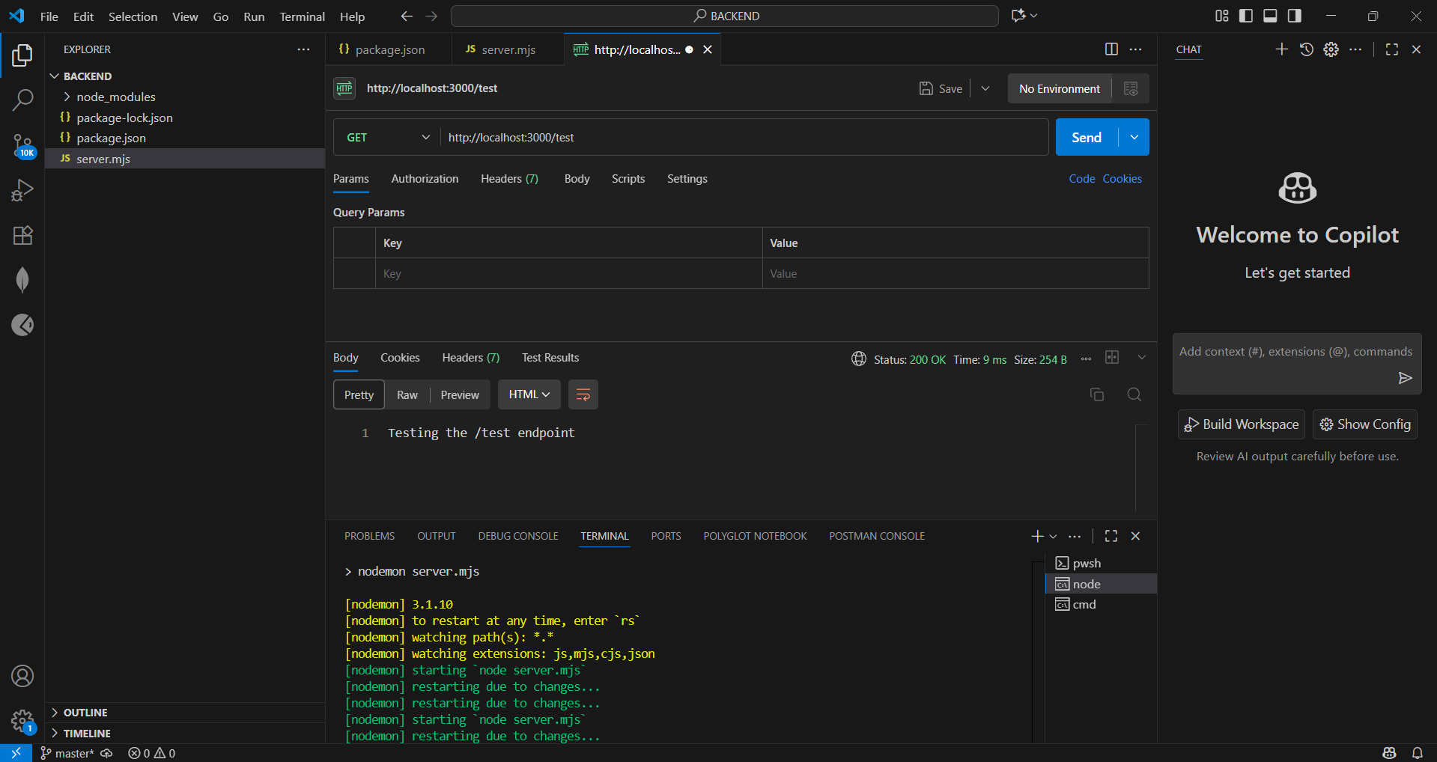

Figure 18: Image showing the get request for the /test endpoint with its results (Mc Harlies, 2025)

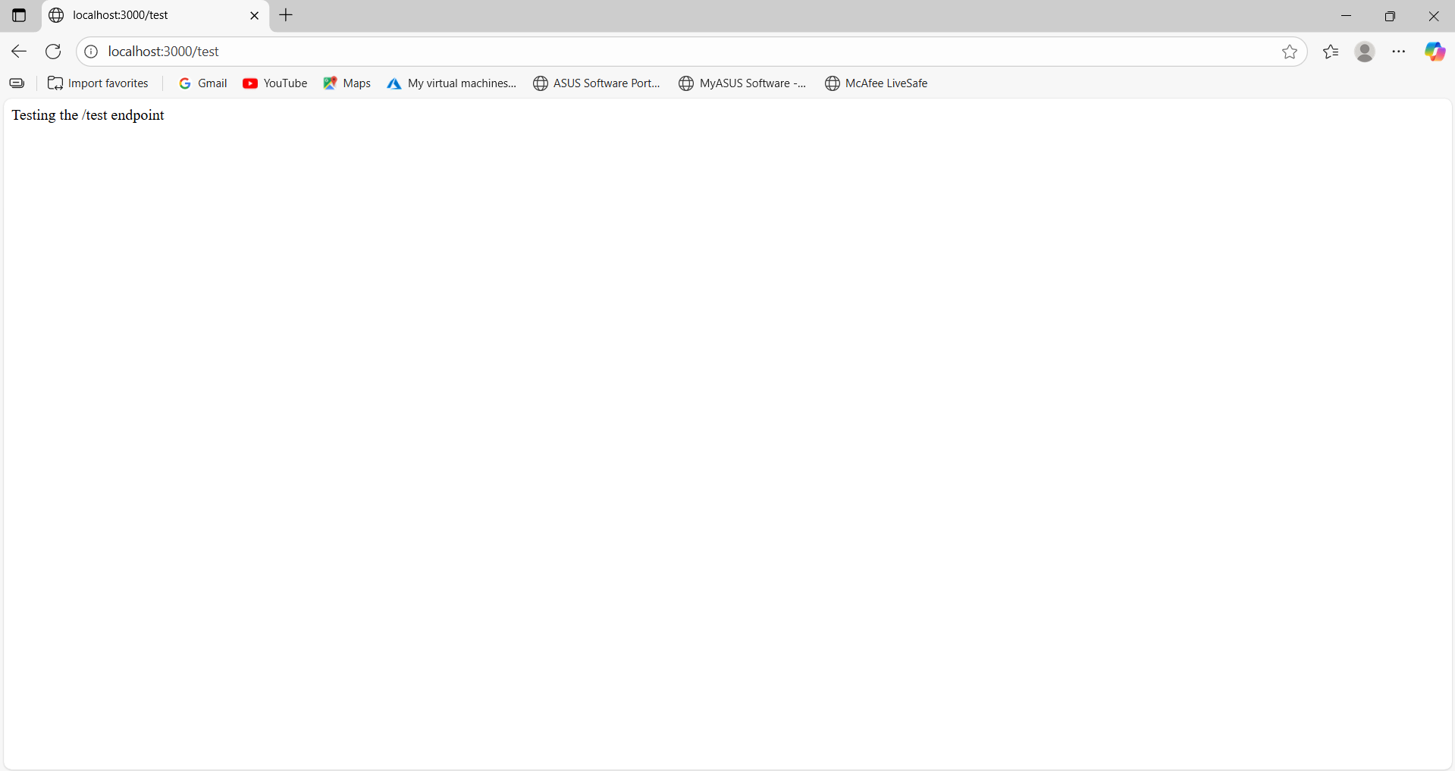

Figure 19: Image showing the output in the web browser after running the node server with the /test endpoint (Mc Harlies, 2025)

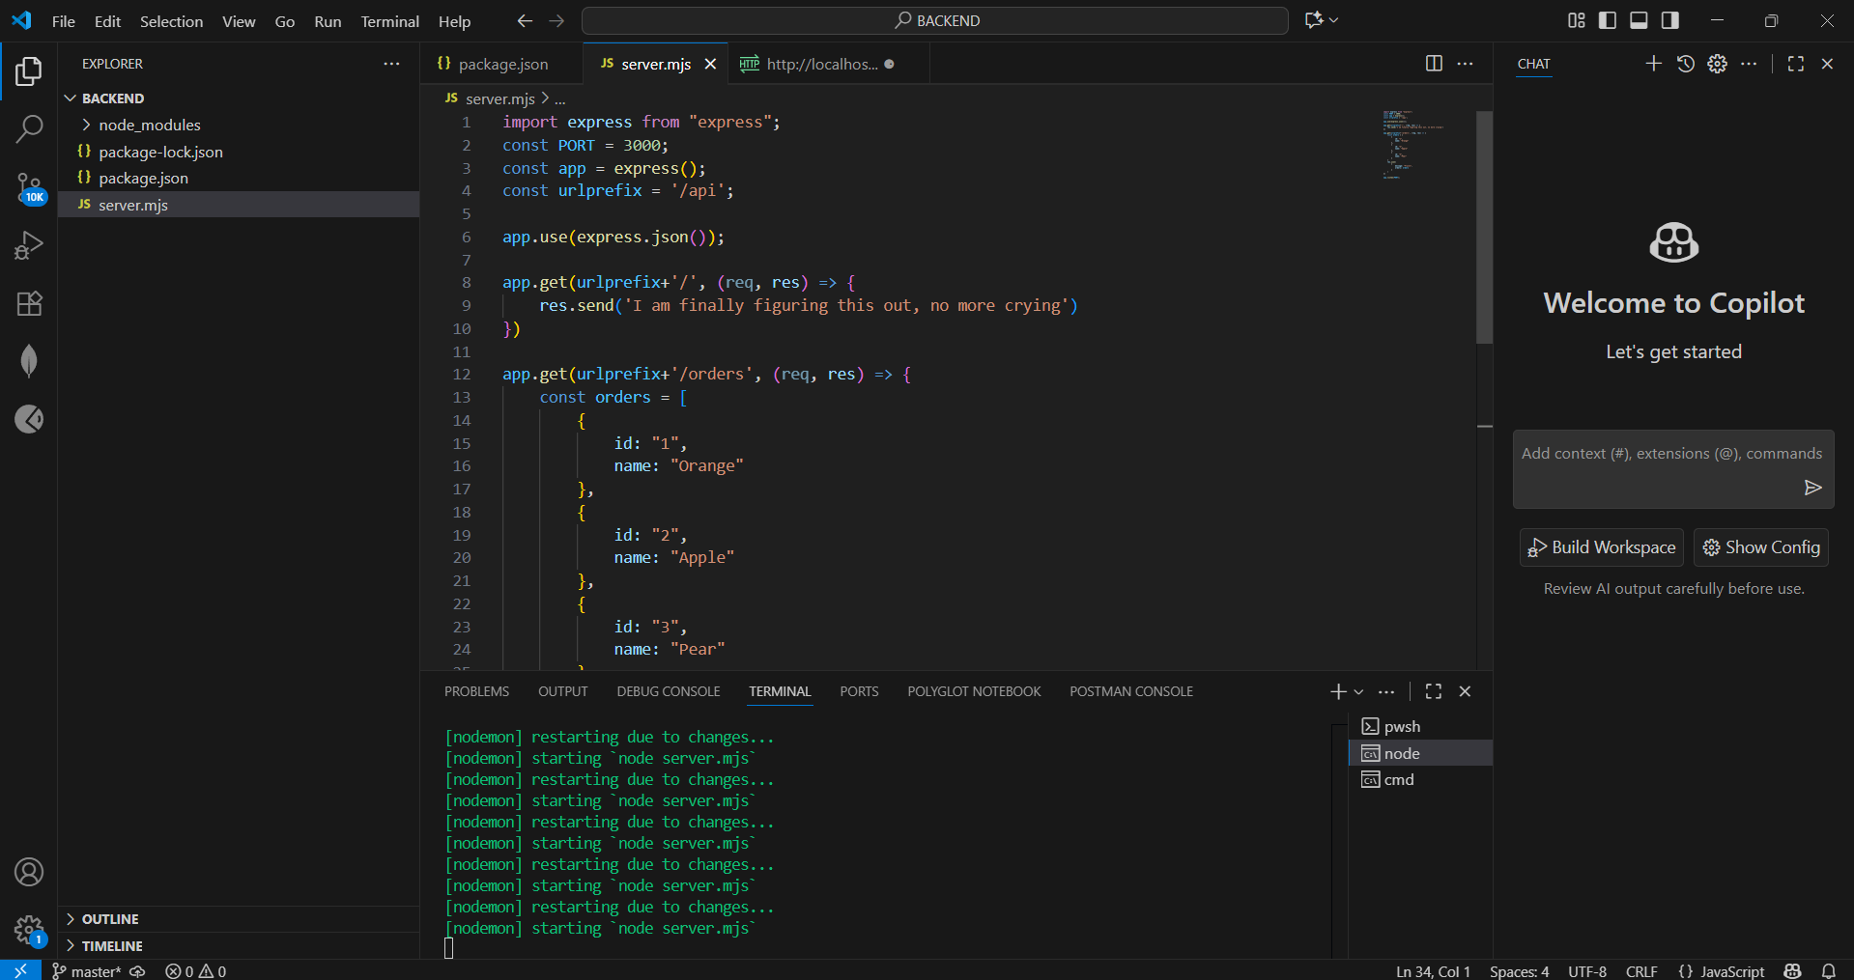

Figure 20: Image showing the changes made to the server.mjs file to return a JSON string (Mc Harlies, 2025)

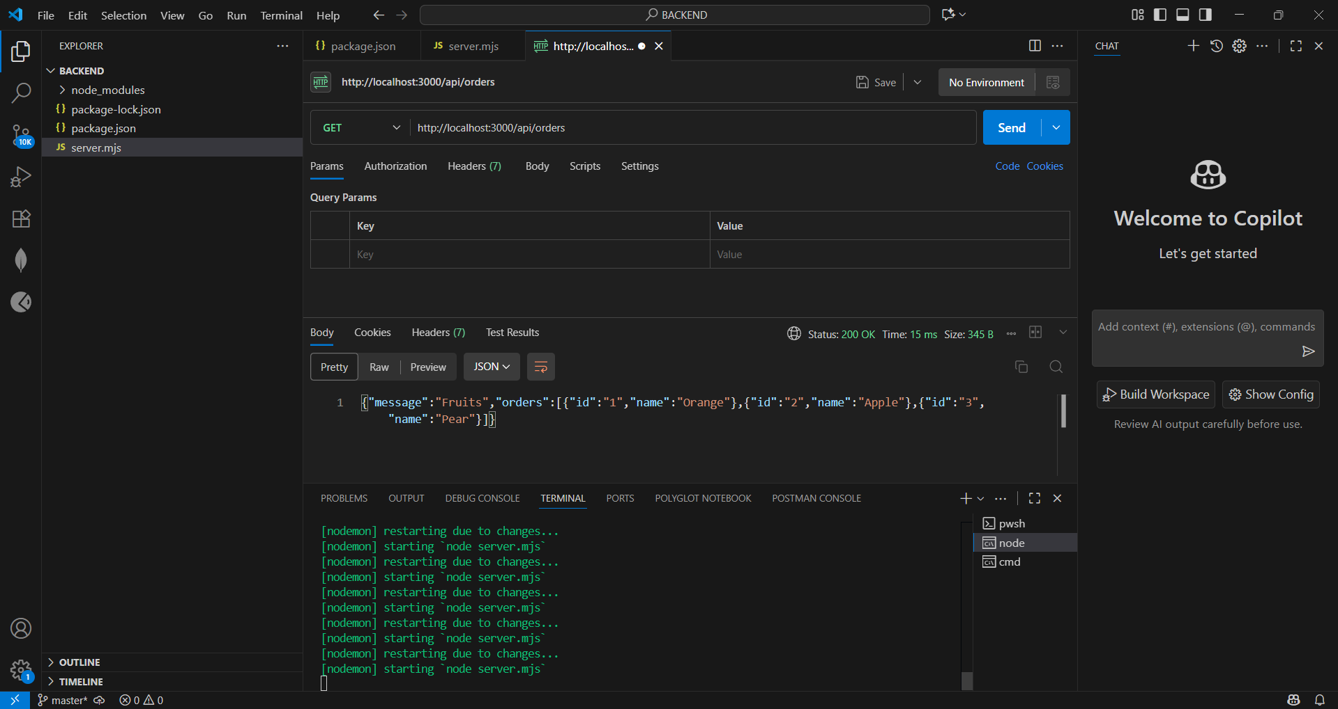

Figure 21: Image showing the get request for the JSON string with its results (Mc Harlies, 2025)

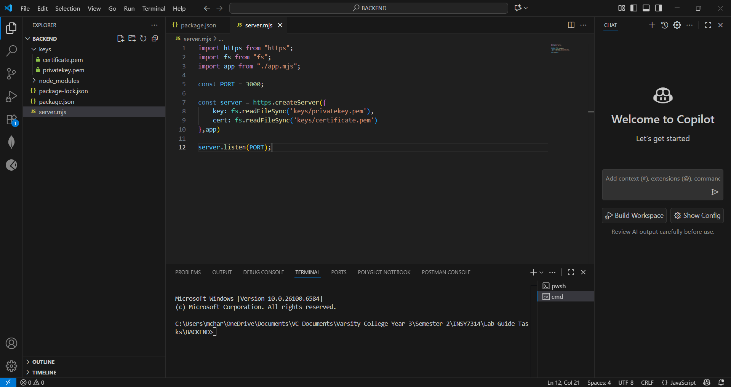

Figure 22: Image showing the inclusion of the two .pem files in the keys folder and in the server.mjs file (Mc Harlies, 2025)

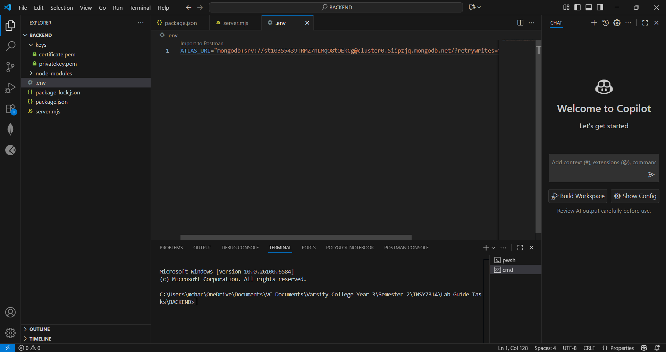

Figure 23: Image showing the .env file containing the MongoDB connection string (Mc Harlies, 2025)

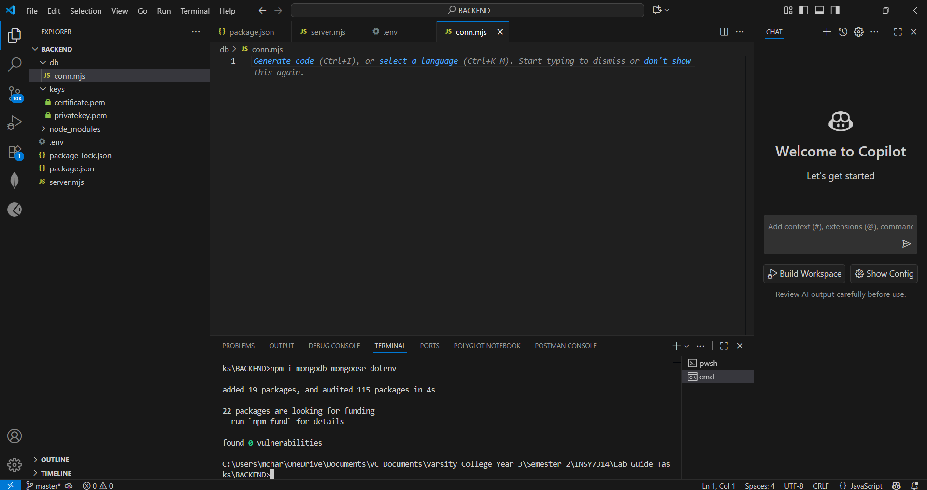

Figure 24: Image showing the creation of the db folder with its conn.mjs file. The image also shows the installation of the MongoDB mongoose dotenv package (Mc Harlies, 2025)

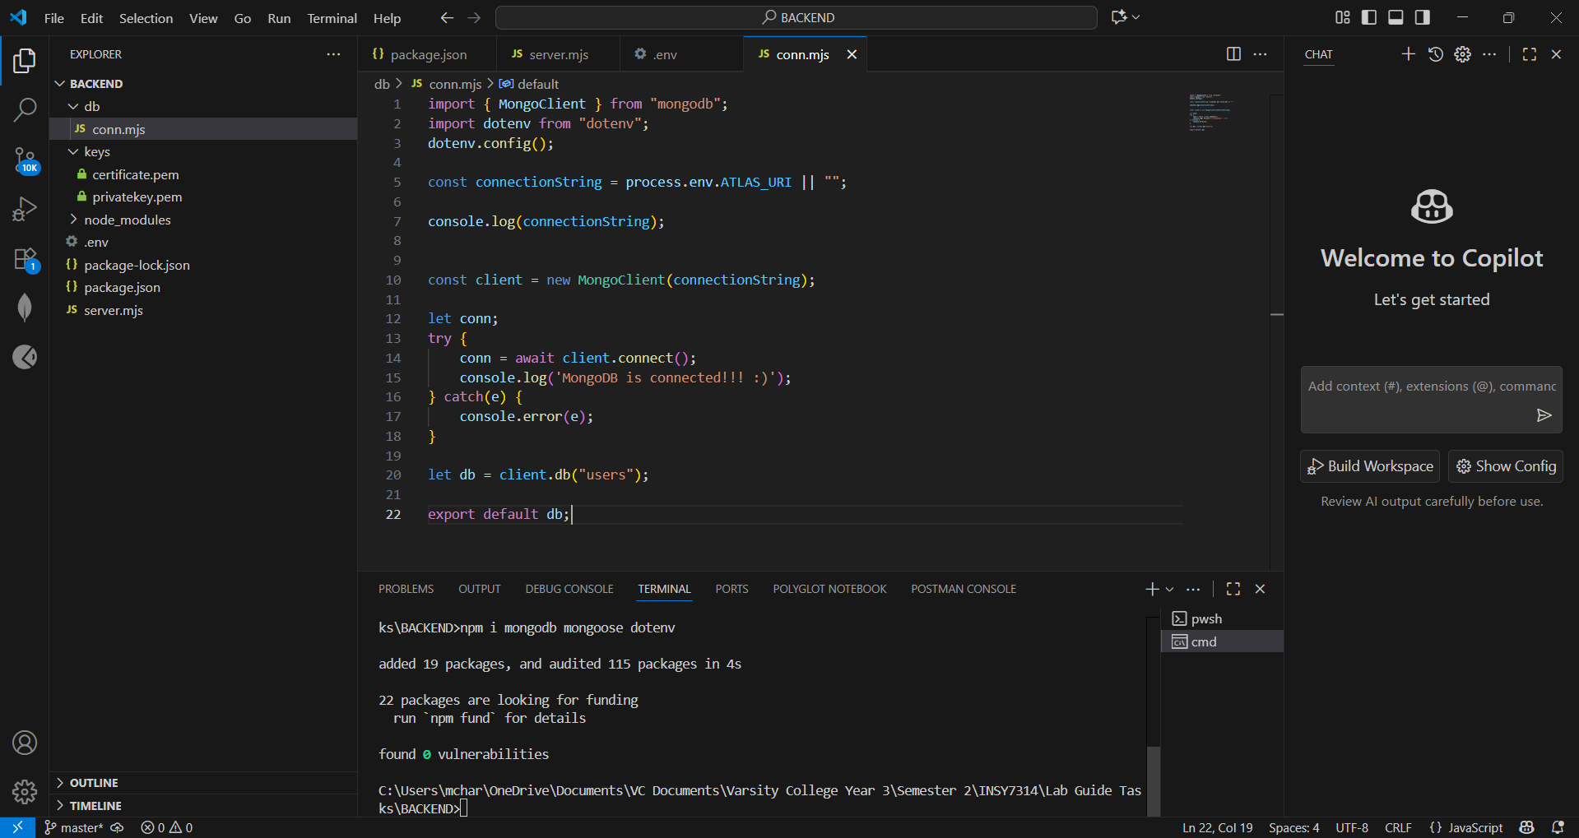

Figure 25: Image showing the changes made to the conn.mjs file to allow connection to the MongoDB database (Mc Harlies, 2025)